|  |
| --- |
| b2c_logo_100e1.jpg |
| Resources for the Blind Inventory System |
| User Manual |
|  |
| **Clarence Carillaga**  **Pauline Gabrielle De Ocampo**  **Phil Harvey Burgos** |
| ©**Asia Pacific College 2015**  **Version History**   |  |  |  | | --- | --- | --- | | **Author** | **Date** | **Version** | | **Pauline De Ocampo** |  | **1.0** | |  |  |  | |

Table of Contents

[SYSTEM DESCRIPTION 3](#_Toc417030031)

[SITE PAGES 3](#_Toc417030032)

[Log In Page 3](#_Toc417030033)

[Getting Started Page 4](#_Toc417030034)

[Index Page 5](#_Toc417030035)

[Customers Page 7](#_Toc417030036)

[Add Customer 8](#_Toc417030037)

[Manage Customers 9](#_Toc417030038)

[Suppliers Page 12](#_Toc417030039)

[Add Supplier 13](#_Toc417030040)

[Manage Suppliers 14](#_Toc417030041)

[Product Inventory Page 17](#_Toc417030042)

[Add Product 18](#_Toc417030043)

[Manage Inventory 19](#_Toc417030044)

[Orders Page 22](#_Toc417030045)

[Add Order 23](#_Toc417030046)

[Manage Orders 24](#_Toc417030047)

[Purchases Page 27](#_Toc417030048)

[Add Purchase Record 28](#_Toc417030049)

[Manage Purchases 29](#_Toc417030050)

[Help Page 32](#_Toc417030051)

[Access Keys 32](#_Toc417030052)

# SYSTEM DESCRIPTION

The Inventory system monitors the daily transactions of Resources of the Blind, Inc. There is a list of existing products, suppliers and customers for easier order inquiry. The system can be accessed with the use of arrow buttons, tab button, shortcut keys and buttons with labels. In addition to these, it can generate annual transactions and orders to suppliers report.

# SITE PAGES

## Log In Page

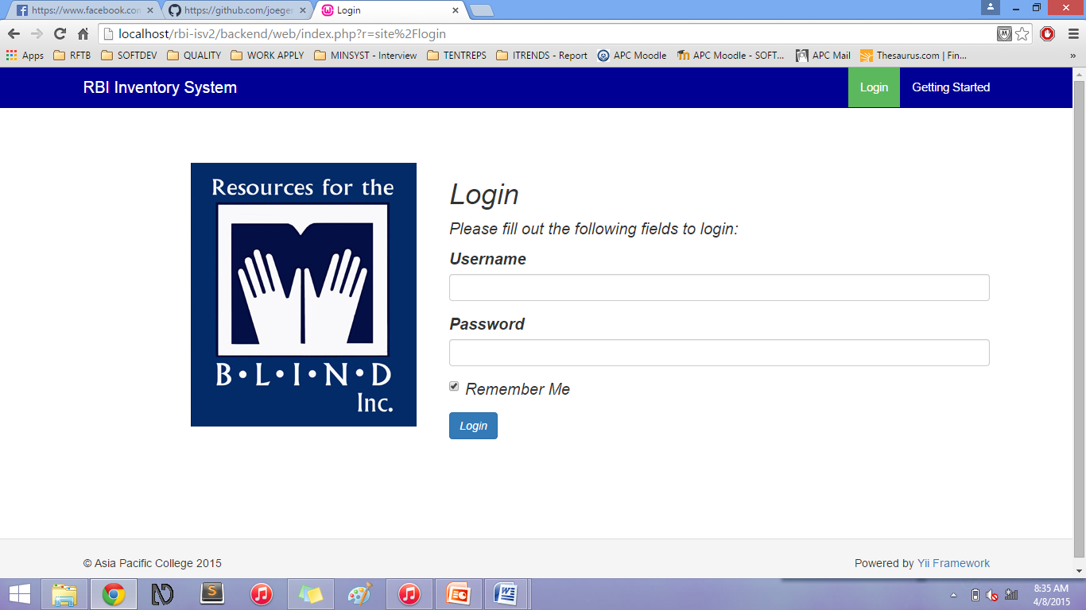

The Log In page of the Resources of the Blind – Inventory System. This will come first before the Index or Home page of the system.

|  |  |
| --- | --- |
| Field | Description |
| Username | Username (user) of the system |
| Password | The respective username’s password |

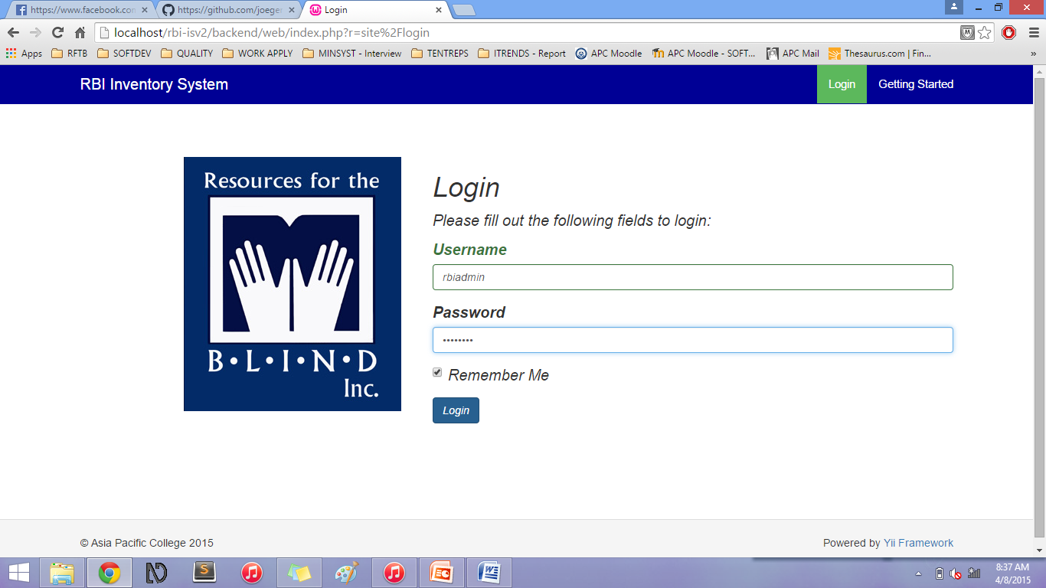

The user will have to input the credentials in order to login into the site.

Below are the following user credentials accepted by the system:

|  |  |
| --- | --- |
| Username | Password |
| rbiadmin | rbiadmin |
| admin | administrator |

After inputting the proper credentials, click the Login Button to go to the Index page of the Inventory System.

## Getting Started Page

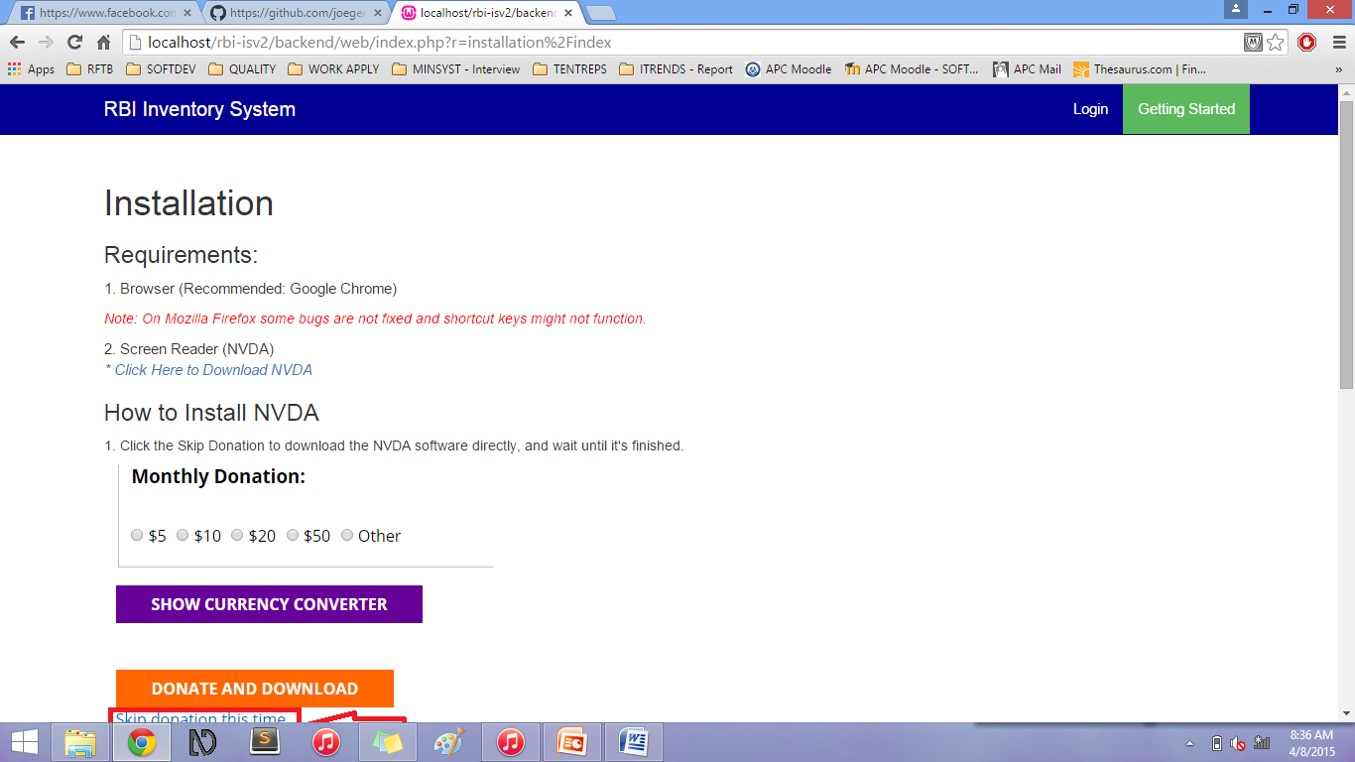

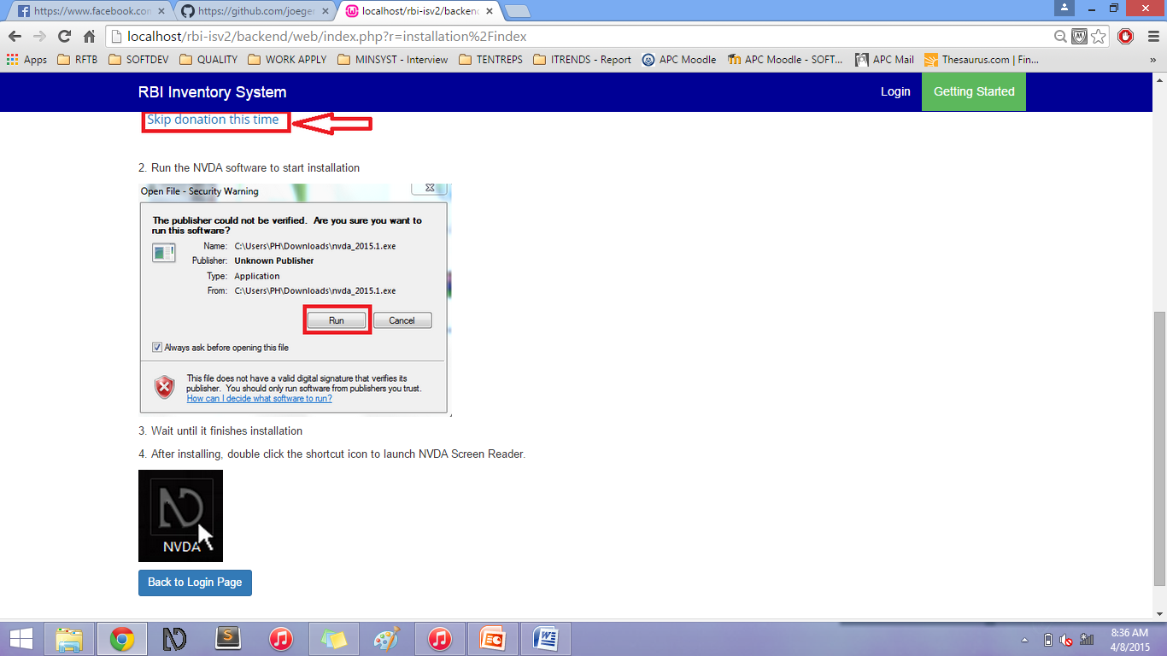

The Getting Started page gives a guide on how to install the recommended screen reader and the sound on click extension. (This is made for visually-impaired users).

## Index Page

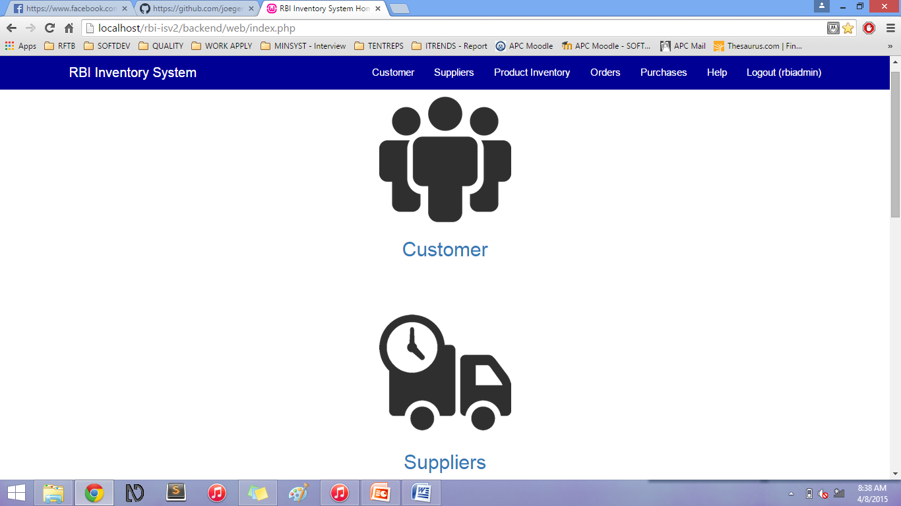

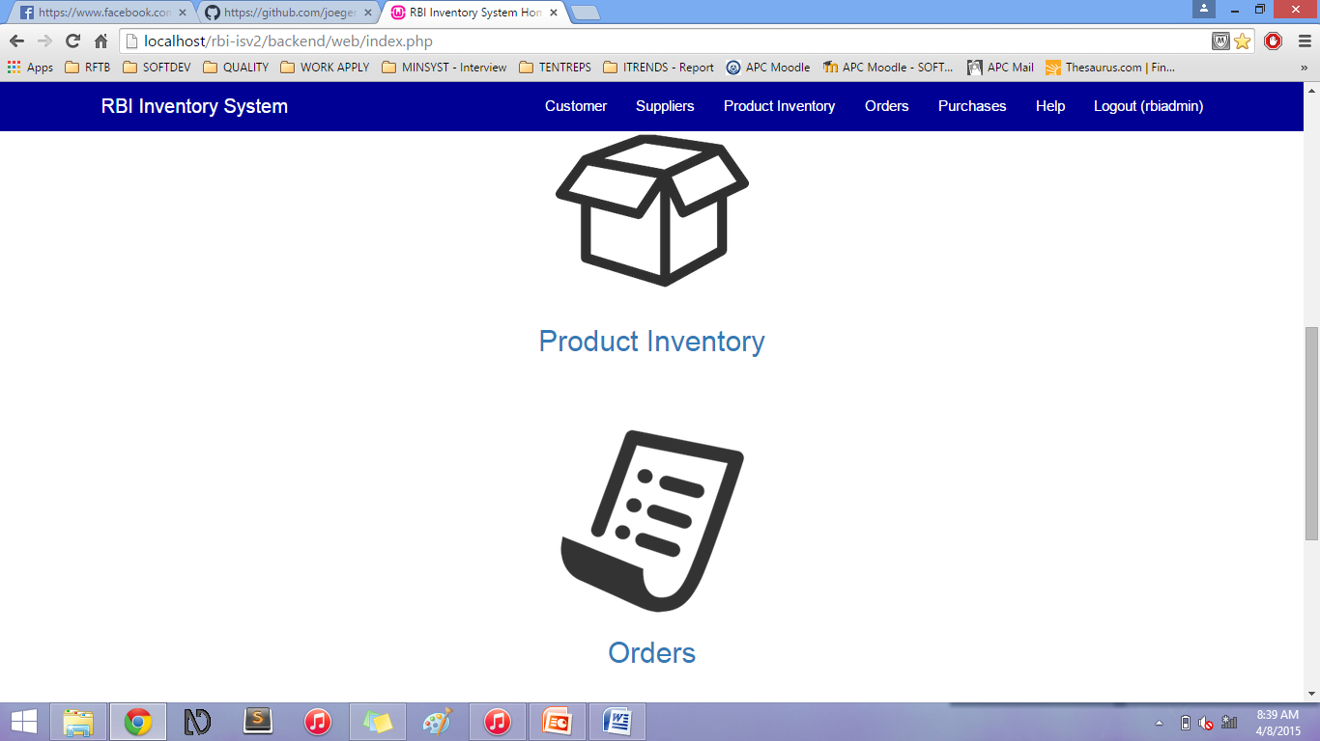

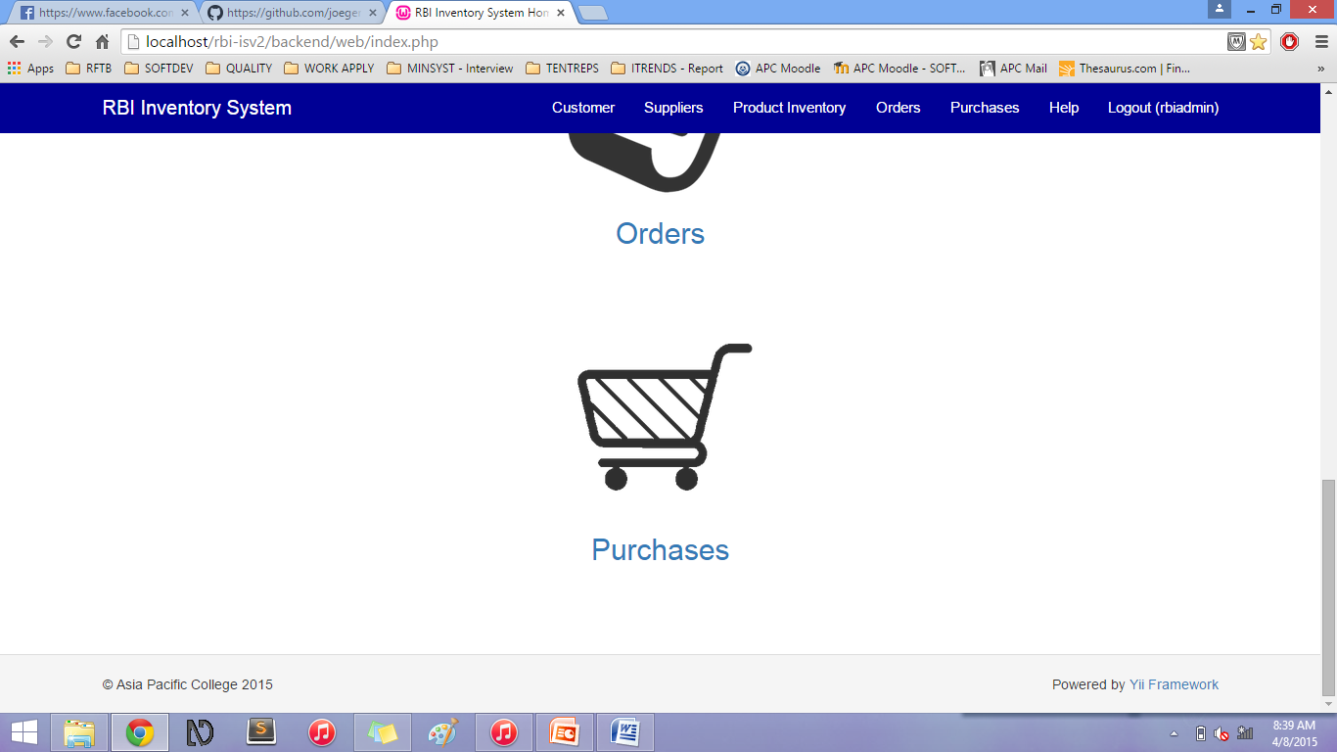

The Index Page / Home page appears when the user logs in into the system. These are the following graphic icons and links:

* Customer – when clicked, goes to the list of Customers page
* Suppliers - when clicked, goes to the list of Suppliers page
* Product Inventory - when clicked, goes to the list of Products page
* Orders - when clicked, goes to the list of Orders (to Suppliers) page
* Purchases - when clicked, goes to the list of Purchases (of the Customers) page

## Customers Page

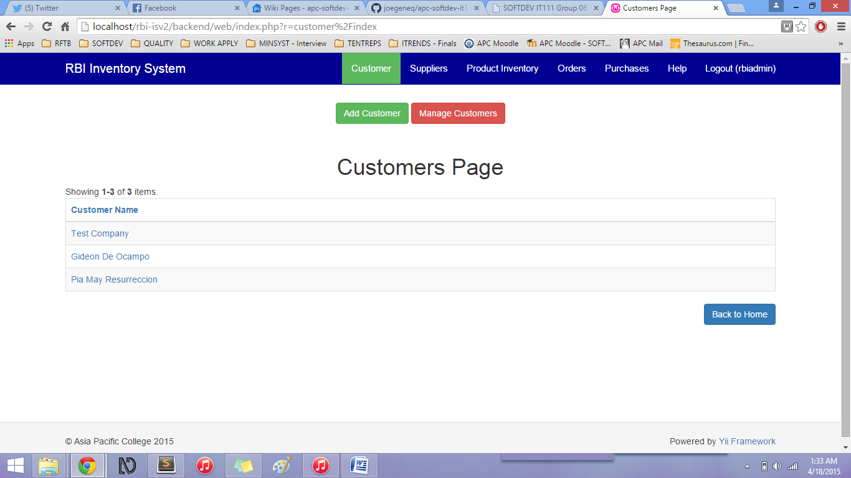

The Customers page shows a table which includes the list of the Customers who can purchase the products of Resources for the Blind.

Add Customer button – when clicked, it will go to the Add Customer form

Manage Customers button – when clicked, it will go to the Manage Customers page

The Customers page table includes the following columns and its data:

* Customer Name (link)

Back to Home button - when clicked, it will go back to the Home page

### Add Customer

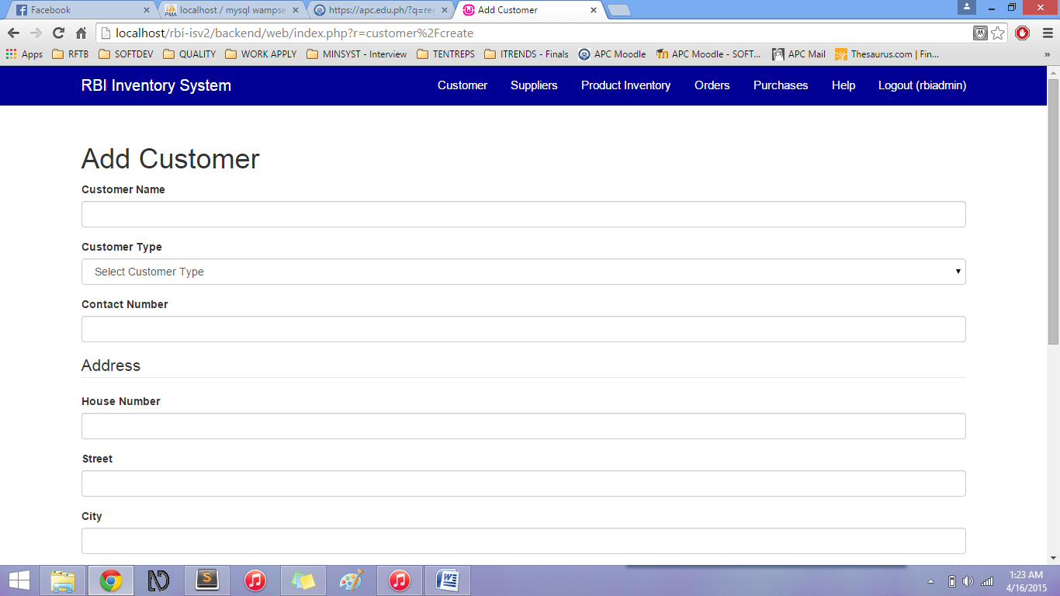

In the Add Customer form, the user will have to input the information of the new Customer.

|  |  |
| --- | --- |
| Field | Description |
| Customer Name\* | Name of the Customer (Individual) or Company |
| Customer Type\* | The types of customers:   * Company * Individual |
| Contact Number\* | The contact number of the Customer |
| Home Number\* | The home number of the address of the Customer |
| Street\* | The street of the address of the Customer |
| City\* | The city of the address of the Customer |
| Zip Code | The zip code of the address of the Customer |
| Country\* | The country of the address of the Customer |
| Email\* | The email address of the Customer |
| Contact Person | This is optional; if the Customer type is Company, this is the name of the Contact Person of the Company |

All fields with (\*) are required.

Click Create button to save Customer information.

Or Click Back to Customers Page to cancel the customer creation.

### Manage Customers

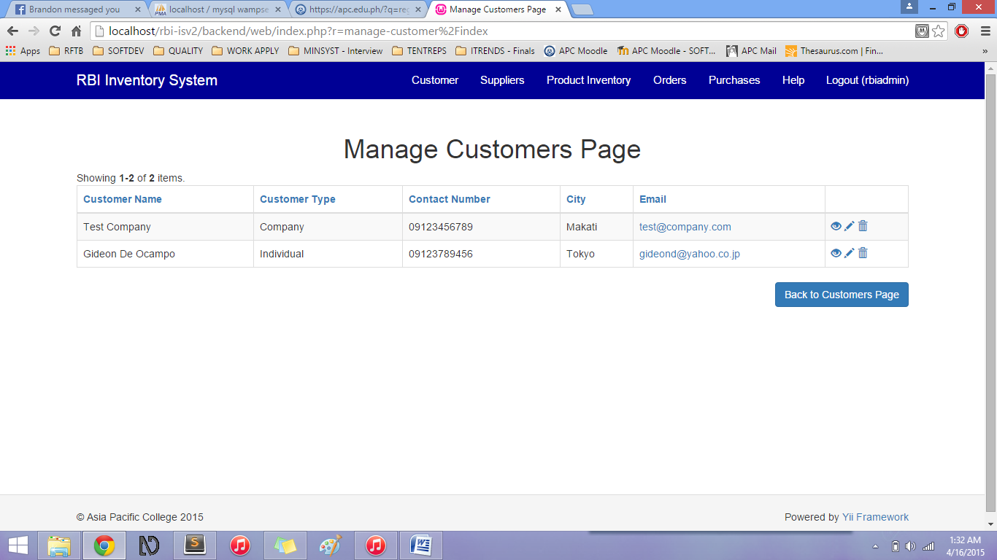

The user can view, update, and delete customer information in the Manage Customers Page using the icons on the right side (column name is blank):

* Eye icon – views chosen customer information
* Pencil icon – edits chosen customer information
* Trash bin icon – deletes chosen customer information

#### Manage Customers – View

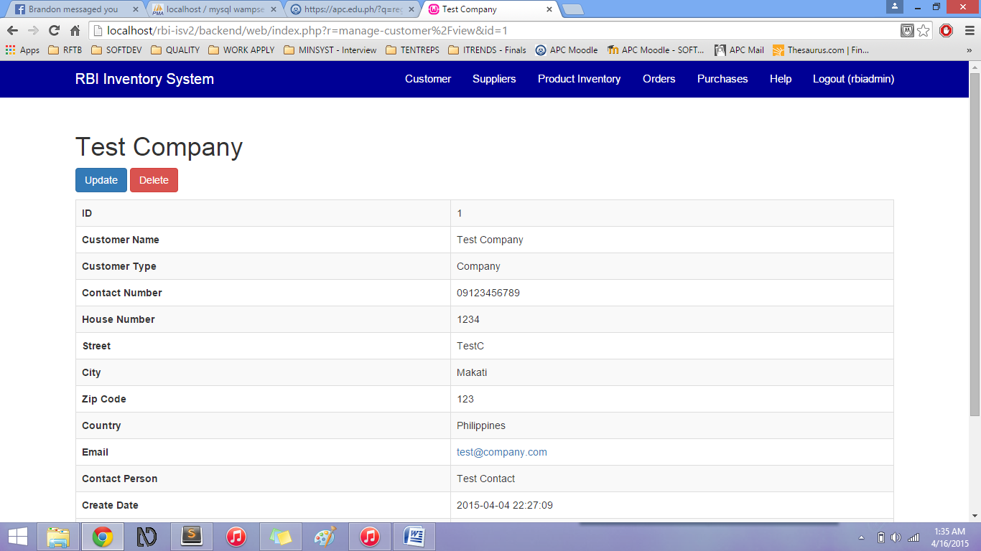

The View function (eye icon) shows the chosen customer information.

You can also Update and Delete the information in this page.

You can also go Back to Manage Customers Page after viewing the information.

#### Manage Customers – Update

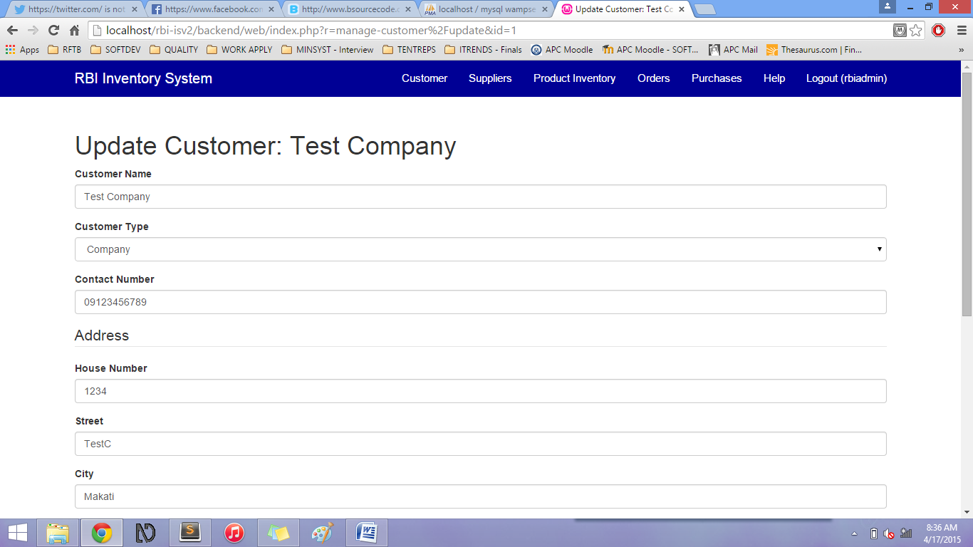

You can update the customer information by clicking the Pencil icon.

Save the updated information by clicking the Update button.

You can go back to Customers Page by clicking the Back to Customers Page button.

#### Customers Page – link (Optional Scenario)

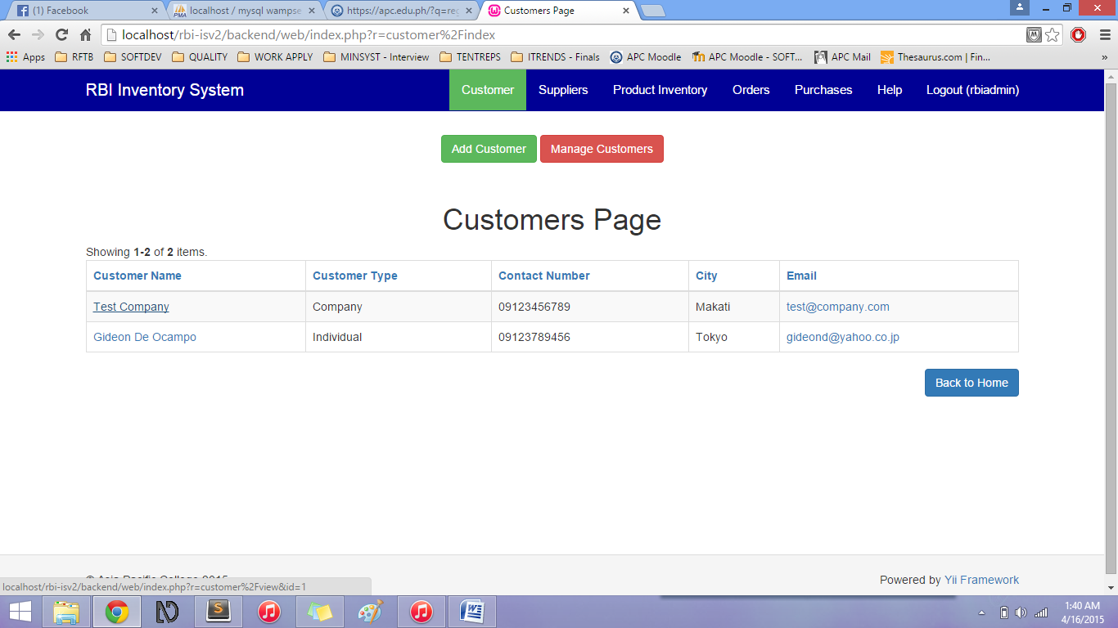

You can also view, update, and delete the Customer information by clicking the link inside the Customer Name column.

#### Customers Page – sorting information

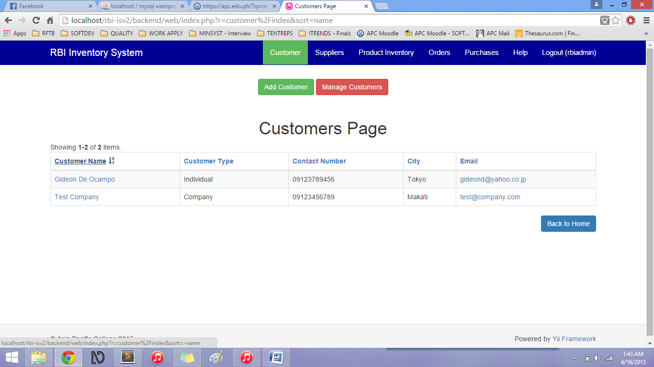

Sort the information presented by clicking on the Column name links. (All column names can be clicked to sort by ascending or descending order).

## Suppliers Page

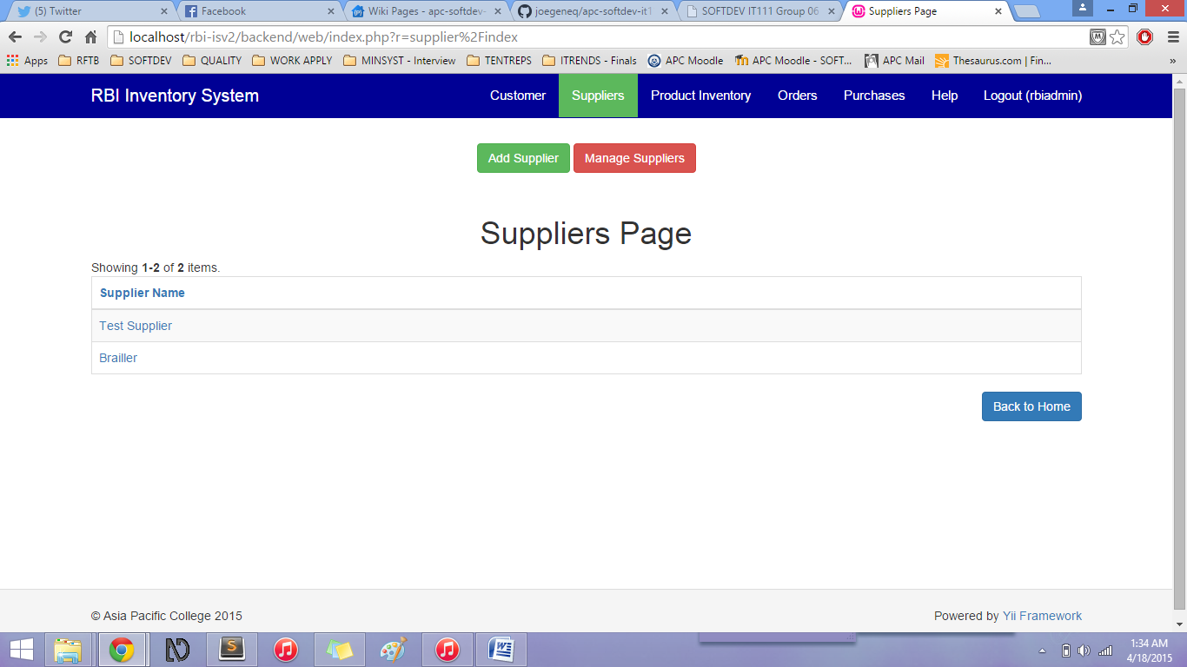

The Suppliers page shows a table which includes the list of the Suppliers who supplies the products of Resources for the Blind.

Add Suppliers button – when clicked, it will go to the Add Supplier form

Manage Suppliers button – when clicked, it will go to the Manage Suppliers page

The Suppliers page table includes the following columns and its data:

* Supplier Name (link)

Back to Home button - when clicked, it will go back to the Home page

### Add Supplier

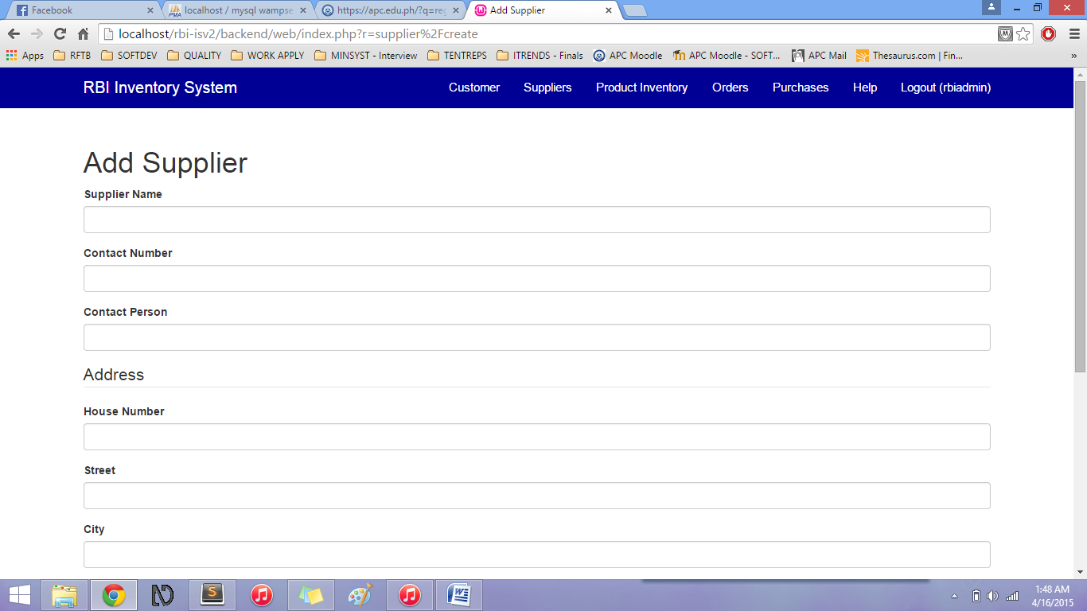

In the Add Supplier form, the user will have to input the information of the new Supplier.

|  |  |
| --- | --- |
| Field | Description |
| Supplier Name\* | Name of the Supplier |
| Contact Number\* | The contact number of the Supplier |
| Contact Person\* | The Contact Person of the Supplier or Supplying Company |
| Home Number\* | The home number of the address of the Supplier |
| Street\* | The street of the address of the Supplier |
| City\* | The city of the address of the Supplier |
| Zip Code | The zip code of the address of the Supplier |
| Country\* | The country of the address of the Supplier |
| Email\* | The email address of the Supplier |

All fields with (\*) are required.

Click Create button to save Supplier information.

Or Click Back to Suppliers to cancel the Supplier creation.

### Manage Suppliers

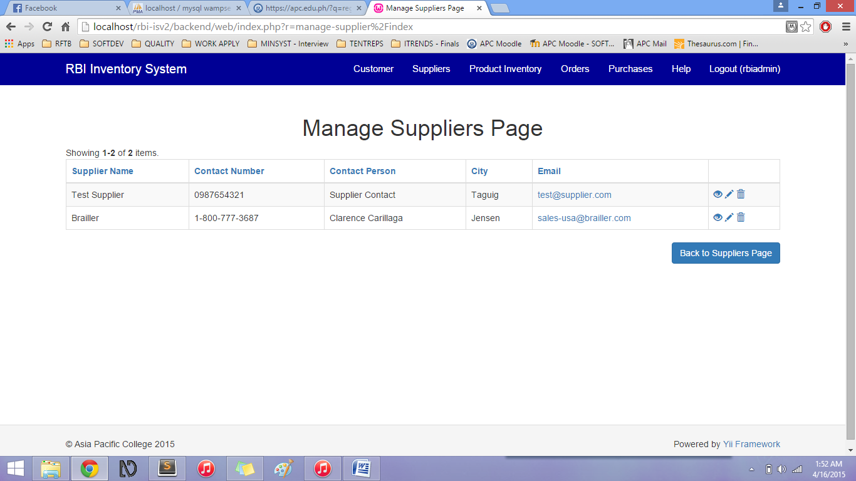

The user can view, update, and delete supplier information in the Manage Suppliers Page using the icons on the right side (column name is blank):

* Eye icon – views chosen supplier information
* Pencil icon – edits chosen supplier information
* Trash bin icon – deletes chosen supplier information

#### Manage Suppliers – View

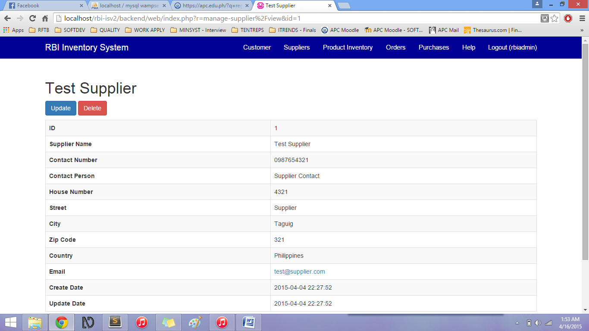

The View function (eye icon) shows the chosen supplier information.

You can also Update and Delete the information in this page.

You can also go Back to Manage Suppliers Page after viewing the information.

#### Manage Suppliers – Update

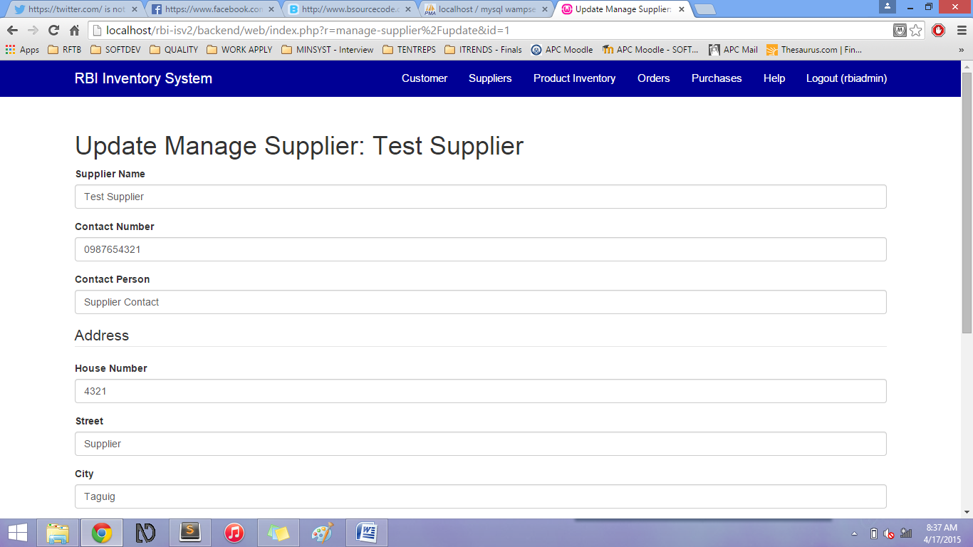

You can update the supplier information by clicking the Pencil icon.

Save the updated information by clicking the Update button.

You can go back to Suppliers Page by clicking the Back to Suppliers Page button.

#### Suppliers Page – link (Optional Scenario)

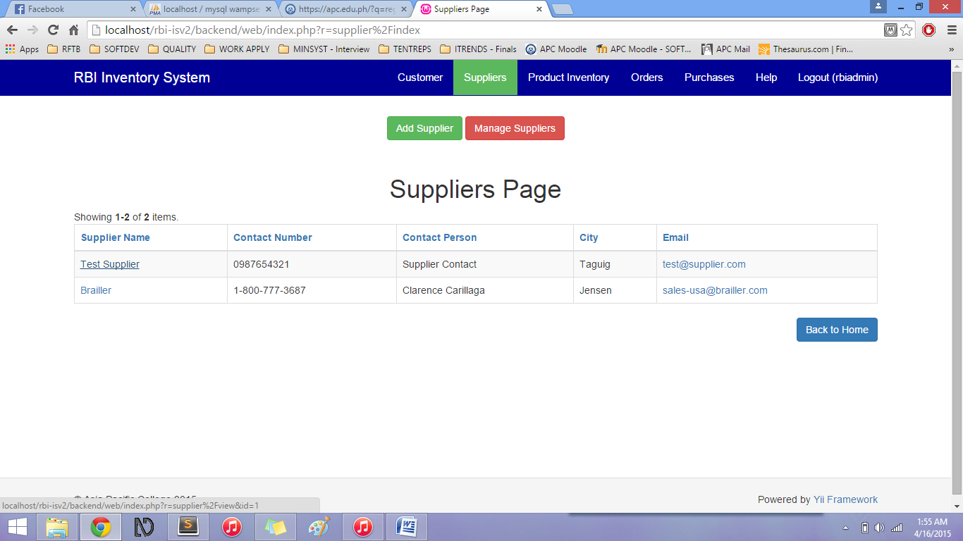

You can also view, update, and delete the Supplier information by clicking the link inside the Supplier Name column.

#### Suppliers Page – sorting information

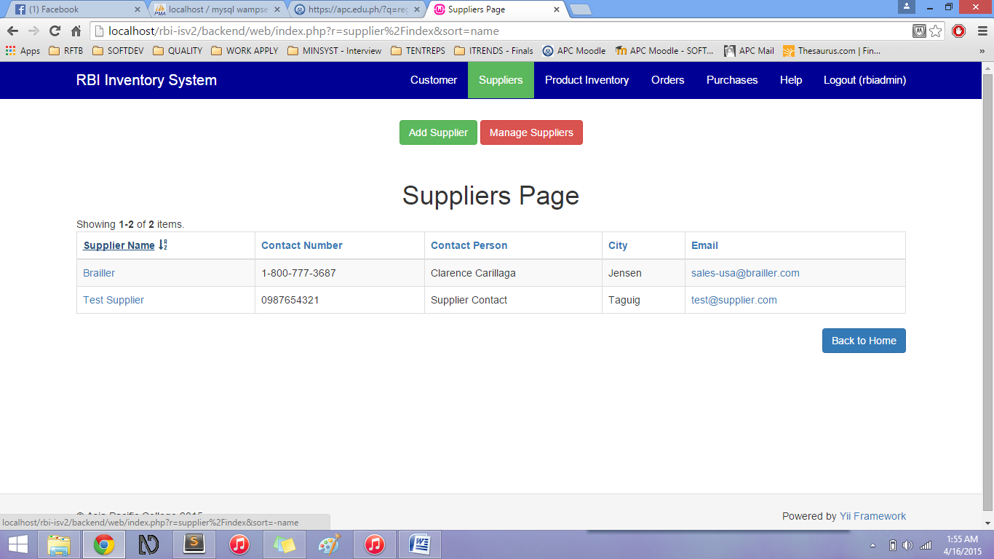

Sort the information presented by clicking on the Column name links. (All column names can be clicked to sort by ascending or descending order).

## Product Inventory Page

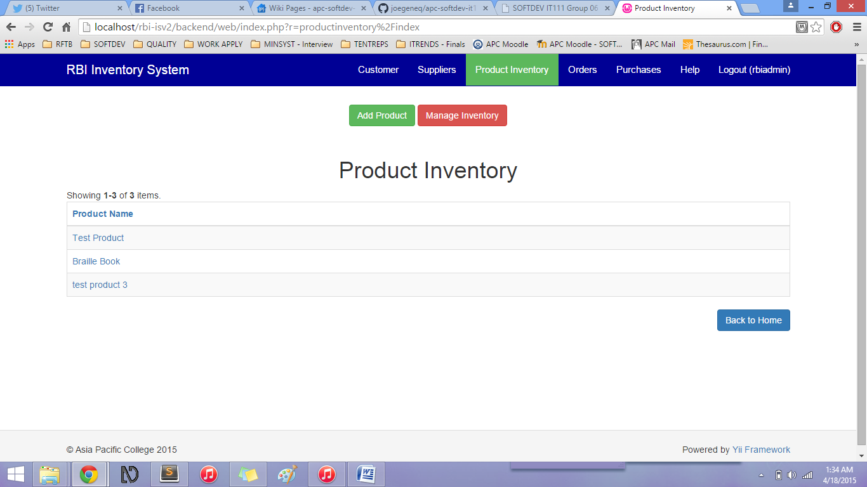

The Product Inventory page shows a table which includes the list of Products that are being sold by Resources of the Blind.

Add Product button – when clicked, it will go to the Add Product form

Manage Inventory button – when clicked, it will go to the Manage Inventory page

The Product Inventory page table includes the following columns and its data:

* Product Name (link)

Back to Home button - when clicked, it will go back to the Home page

### Add Product

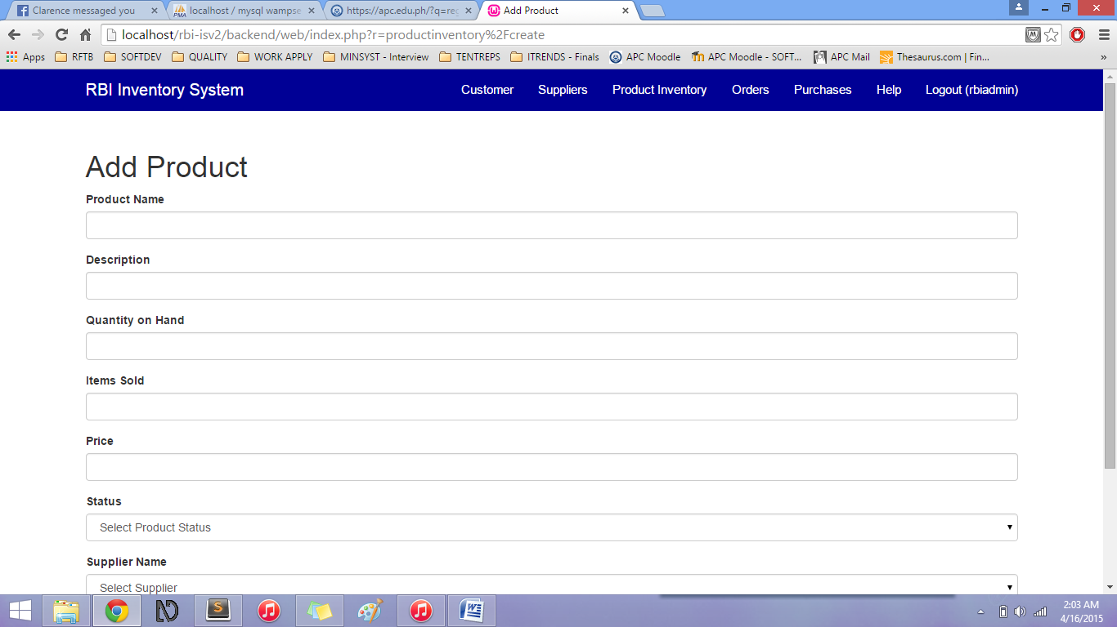

In the Add Product form, the user will have to input the information of the new Product.

|  |  |
| --- | --- |
| Field | Description |
| Product Name\* | Name of the Product |
| Description\* | Description of the product |
| Quantity on Hand\* | The maximum quantity of the product |
| Items Sold\* | The confirmed sold purchases of the product |
| Price\* | Unit price of the product |
| Status\* | The status of the product:   * Available * Out-of-stock |
| Supplier Name\* | Name of the existing Supplier of the product |

All fields with (\*) are required.

Click Create to save Product information.

Or Click Back to Product Inventory to cancel the Product creation.

### Manage Inventory

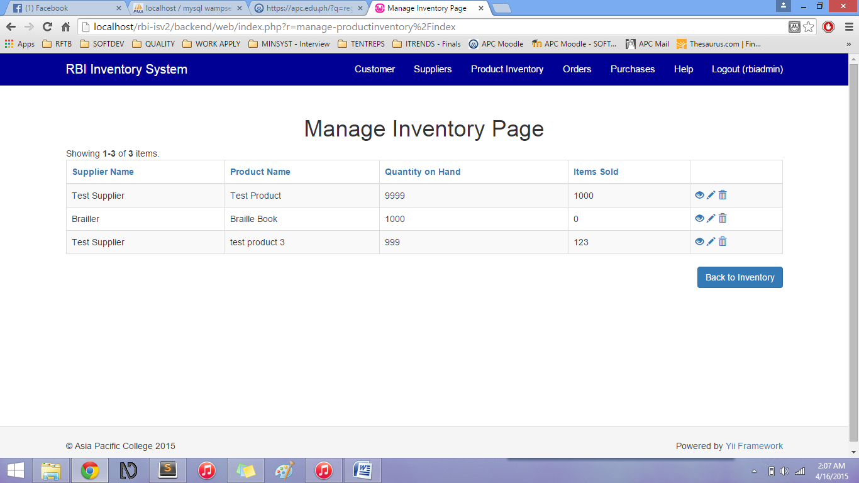

The user can view, update, and delete product information in the Manage Inventory Page using the icons on the right side (column name is blank):

* Eye icon – views chosen product information
* Pencil icon – edits chosen product information
* Trash bin icon – deletes chosen product information

#### Manage Inventory – View

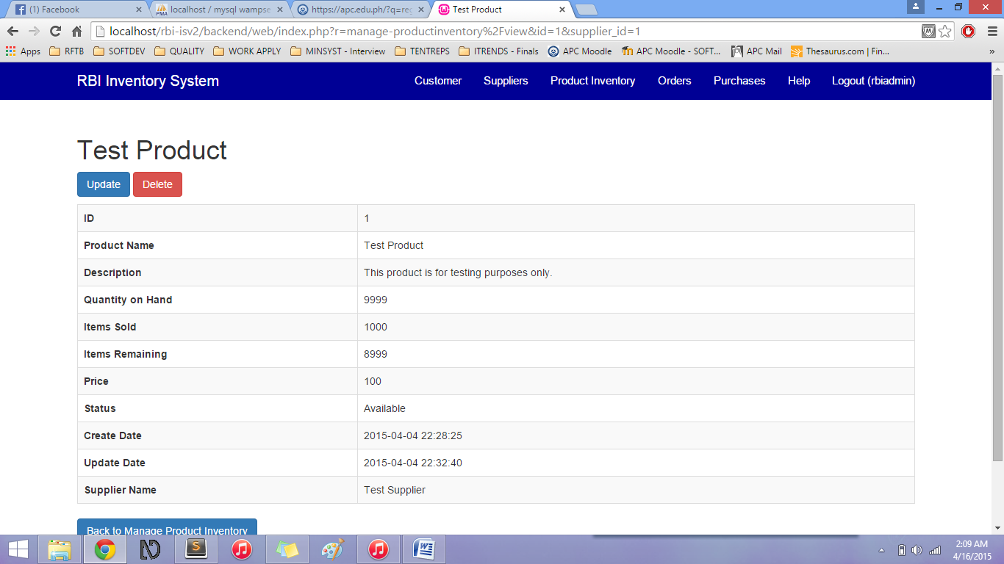

The View function (eye icon) shows the chosen product information.

Additional field: **Items Remaining** – this shows the Quantity on Hand minus (-) the items sold for the particular product.

You can also Update and Delete the information in this page.

You can also go Back to Manage Product Inventory after viewing the information.

#### Manage Inventory – Update

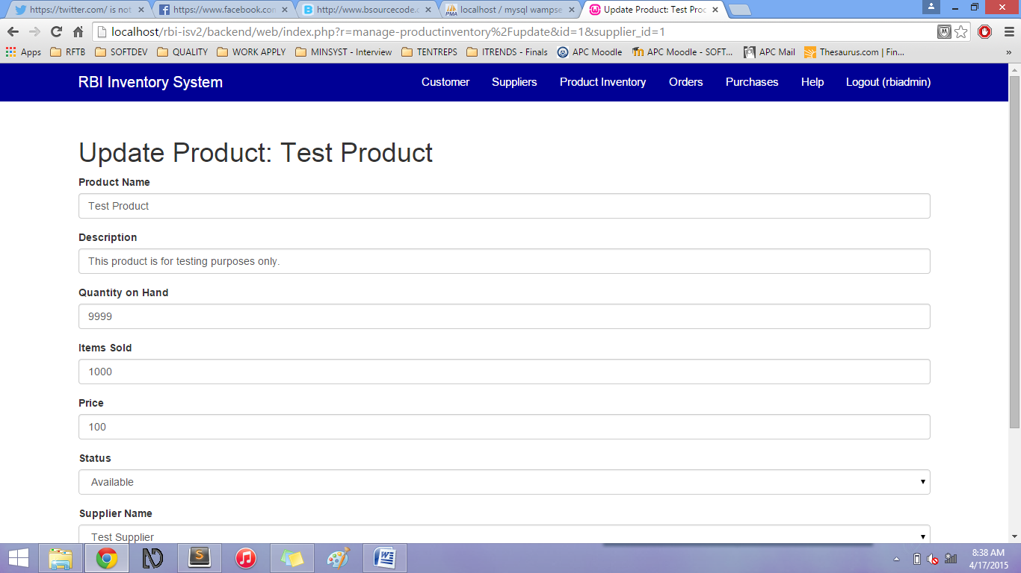

You can update the product information by clicking the Pencil icon.

Save the updated information by clicking the Update button.

You can go back to Product Inventory Page by clicking the Back to Product Inventory button.

#### Product Inventory Page – link (Optional Scenario)

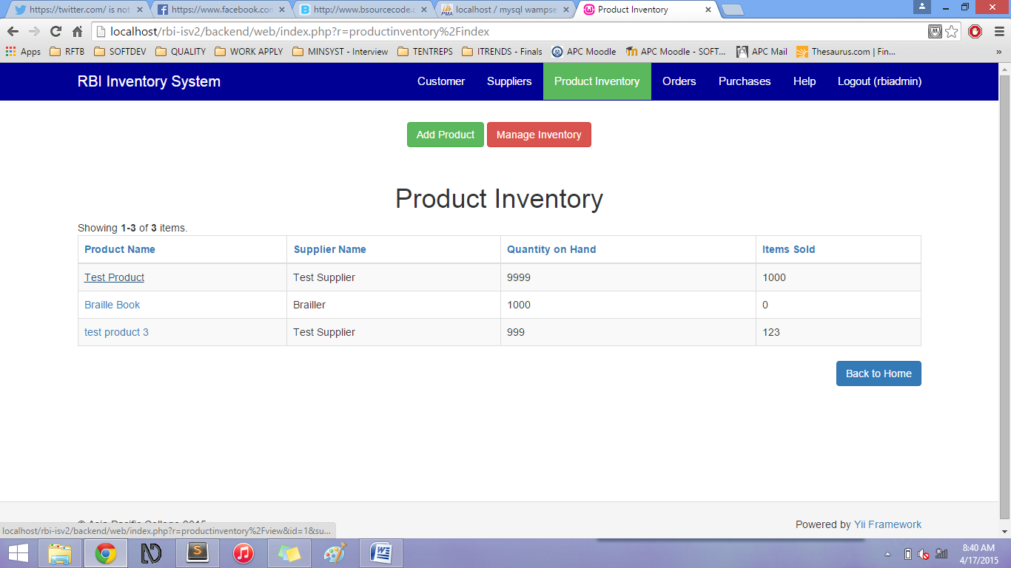

You can also view, update, and delete the Product information by clicking the link inside the Product Name column.

#### Product Inventory Page – sorting information

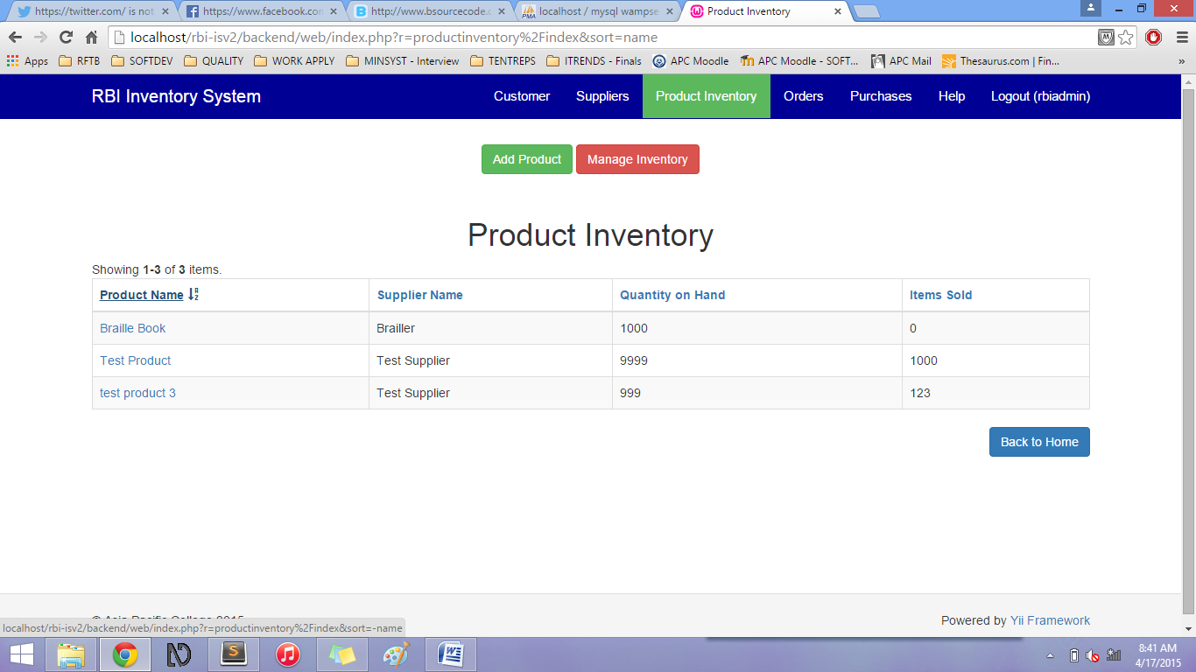

Sort the information presented by clicking on the Column name links. (All column names can be clicked to sort by ascending or descending order).

## Orders Page

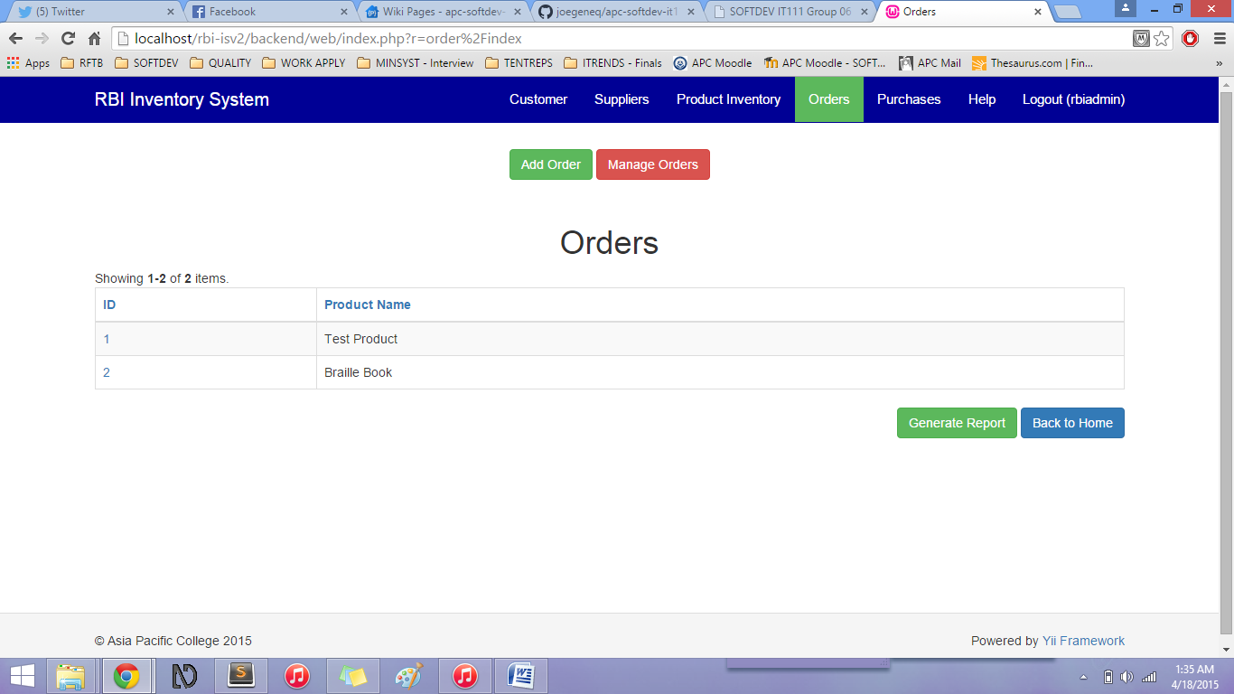

The Orders page shows a table which includes the Order of products to the Suppliers.

Add Order button – when clicked, it will go to the Add Order form

Manage Orders button – when clicked, it will go to the Manage Orders page

The Product Inventory page table includes the following columns and its data:

* Order ID link (*This is auto-generated by the system)*
* Product Name

Back to Home button - when clicked, it will go back to the Home page

Generate Report button – This will generate all the Order to Suppliers reports (via PDF)

### Add Order

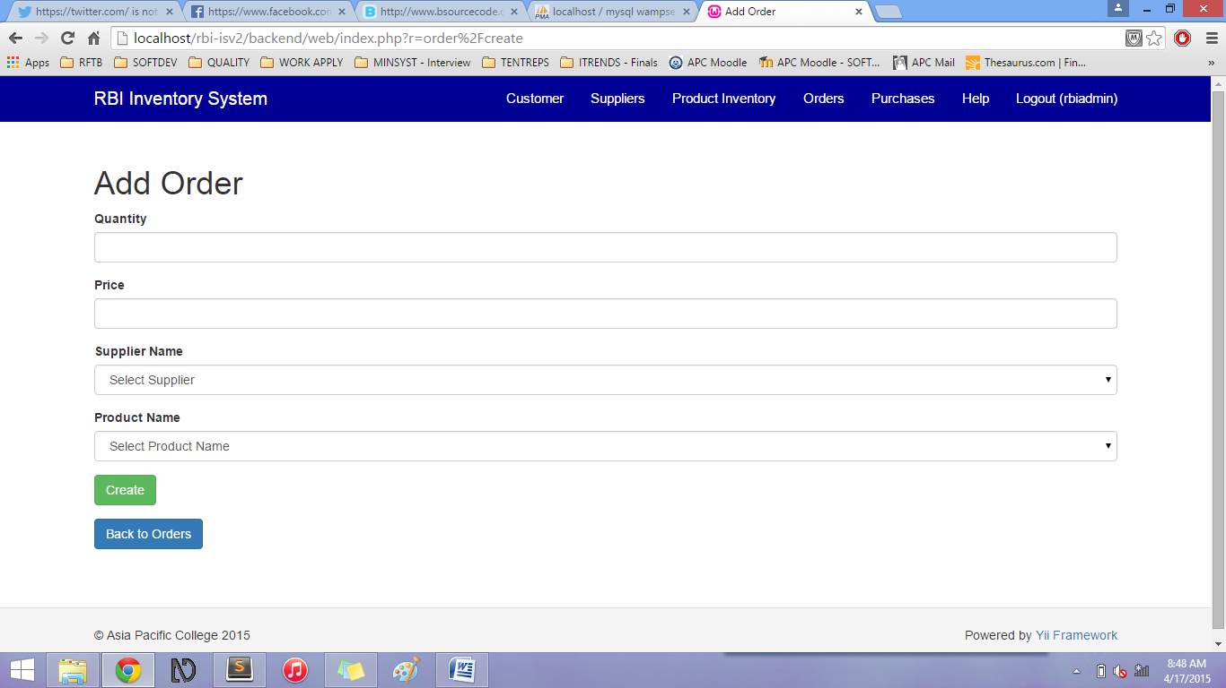

In the Add Order form, the user will have to input the information of the new Order.

|  |  |
| --- | --- |
| Field | Description |
| Quantity\* | Quantity of the Ordered product |
| Price | Price of the ordered product |
| Product Name\* | Name of the existing Product |
| Supplier Name\* | Name of the existing Supplier of the product |

All fields with (\*) are required.

Click Create to save Order information.

Or Click Back to Orders to cancel the Order creation.

### Manage Orders

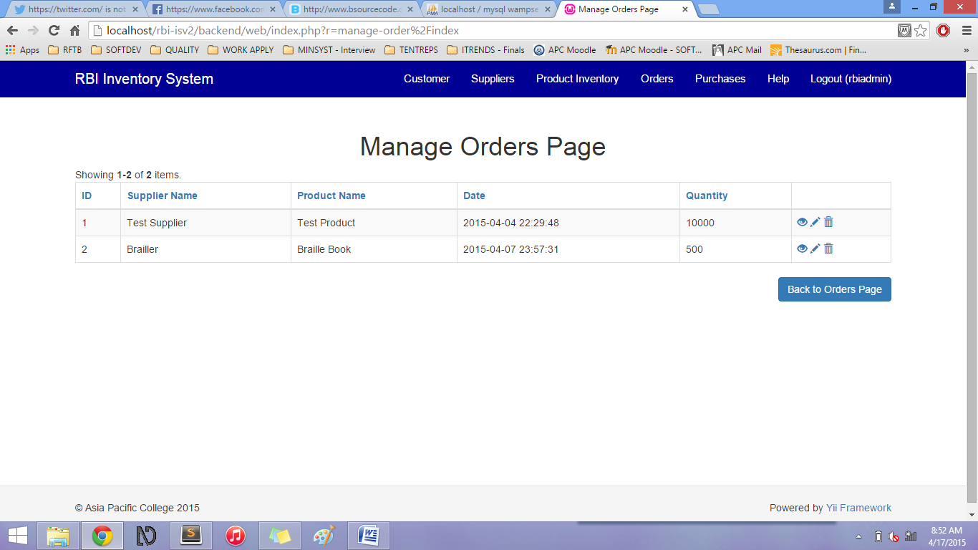

The user can view, update, and delete order information in the Manage Orders Page using the icons on the right side (column name is blank):

* Eye icon – views chosen order information
* Pencil icon – edits chosen order information
* Trash bin icon – deletes chosen order information

#### Manage Orders– View

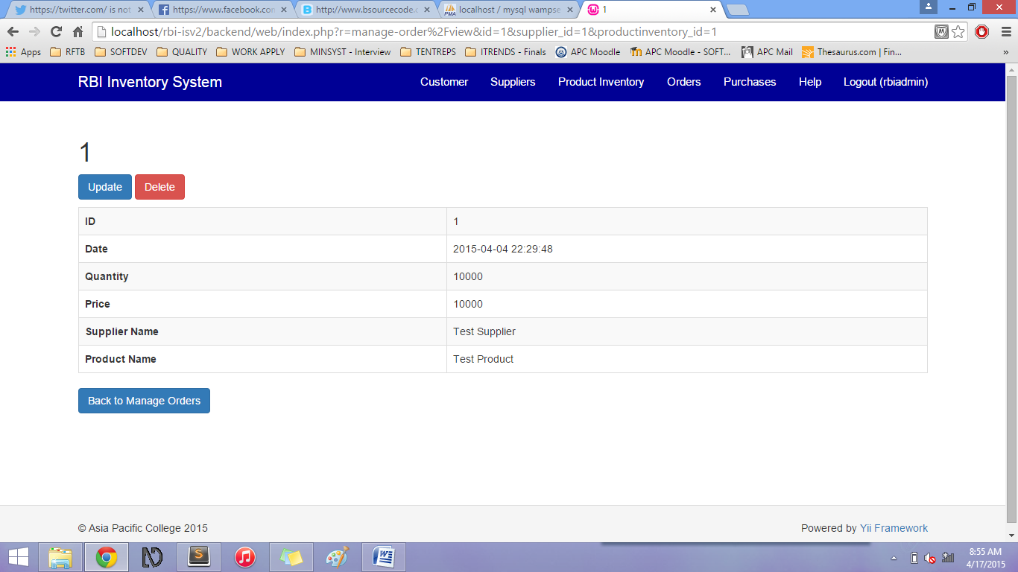

The View function (eye icon) shows the chosen order information.

Additional field: **Date** – this shows the Order date.

You can also Update and Delete the information in this page.

You can also go Back to Manage Orders after viewing the information.

#### Manage Orders– Update

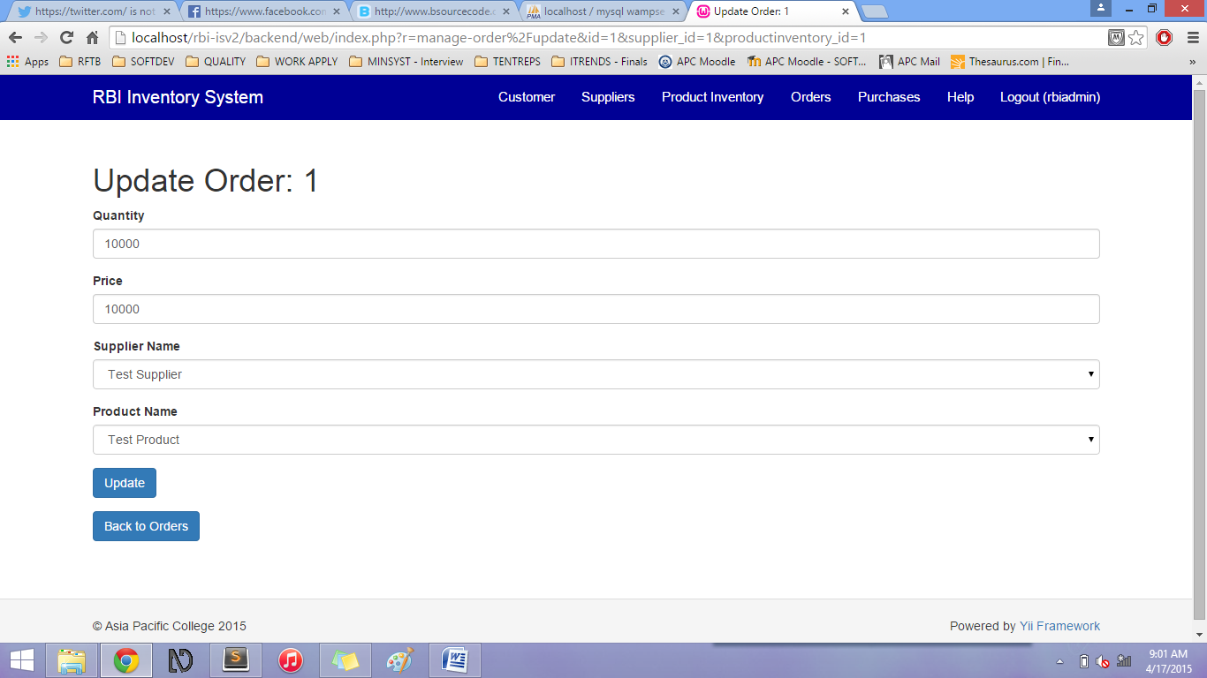

You can update the order information by clicking the Pencil icon.

Save the updated information by clicking the Update button.

You can go back to Orders Page by clicking the Back to Orders button.

#### Orders Page – link (Optional Scenario)

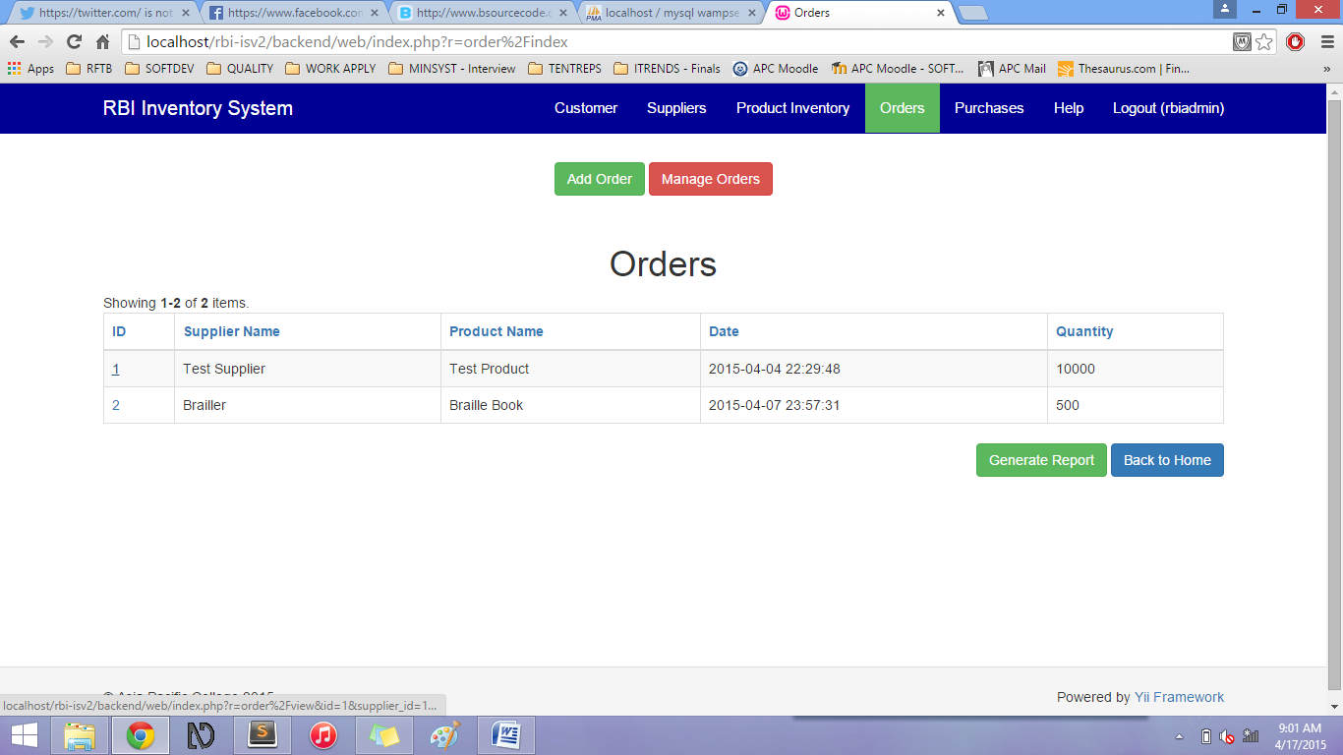

You can also view, update, and delete the Order information by clicking the link inside the Order ID column.

#### Orders Page – sorting information

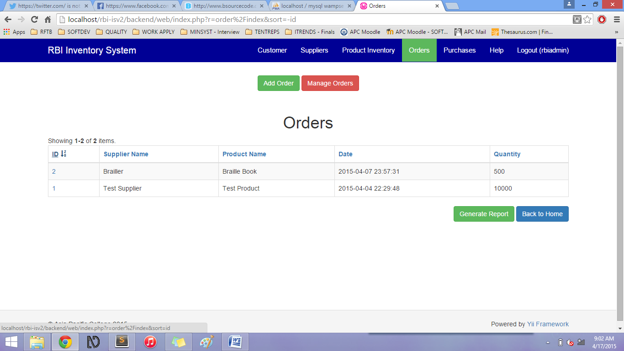

Sort the information presented by clicking on the Column name links. (All column names can be clicked to sort by ascending or descending order).

## Purchases Page

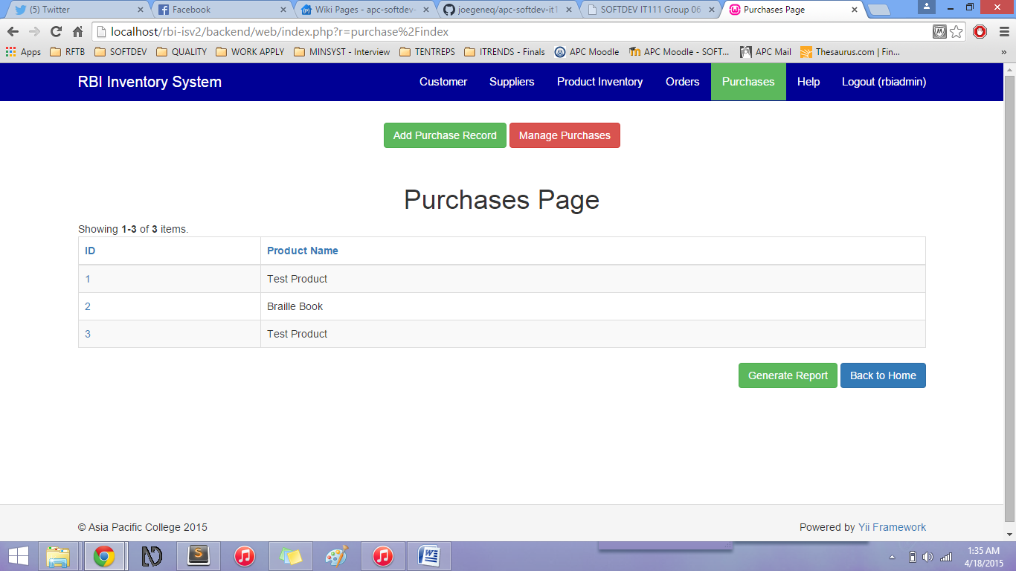

The Purchases page shows a table which includes the Purchases of the Resources for the Blind’s customers.

Add Purchase Record button – when clicked, it will go to the Add Purchase Record form

Manage Purchases button – when clicked, it will go to the Manage Purchases page

The Purchases page table includes the following columns and its data:

* Purchase ID link (*This is auto-generated by the system)*
* Product Name

Back to Home button - when clicked, it will go back to the Home page

Generate Report button – This will generate all *confirmed* purchases (via PDF)

### Add Purchase Record

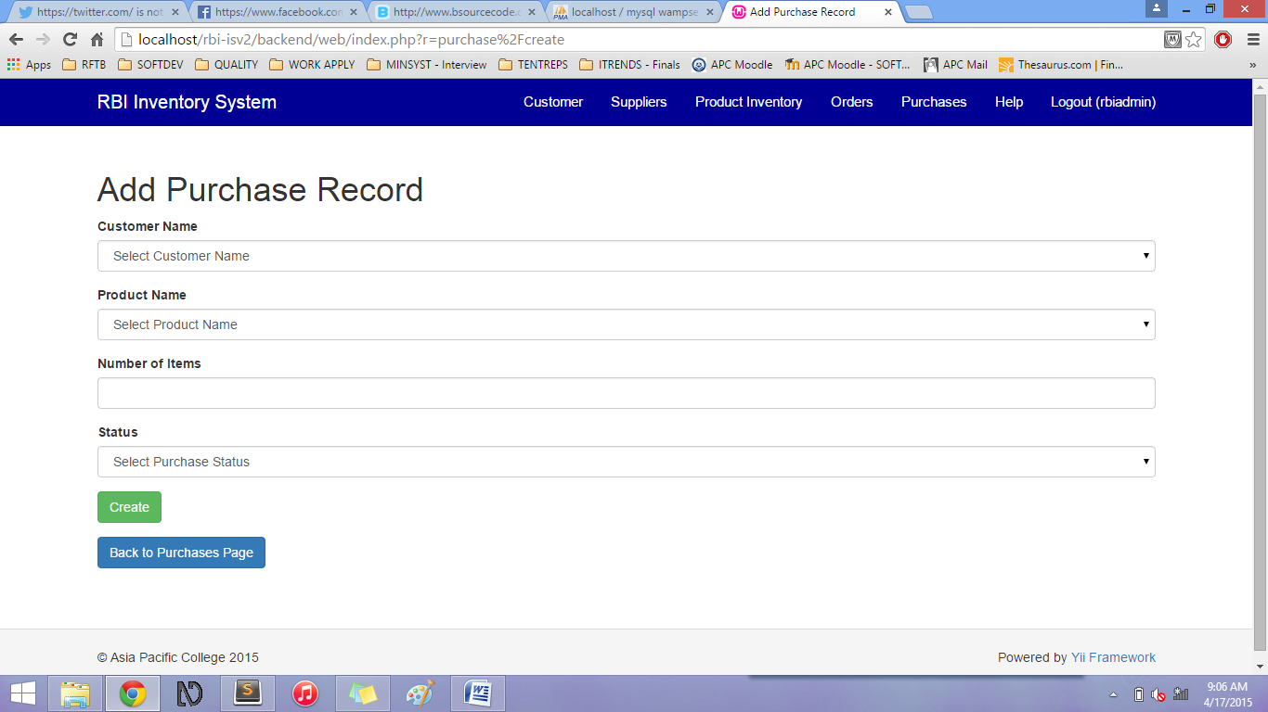

In the Add Purchase Record form, the user will have to input the information of the new Purchase.

|  |  |
| --- | --- |
| Field | Description |
| Customer Name\* | Name of the Customer who purchased the product |
| Product Name\* | Name of the Product purchased |
| Number of Items\* | Number of items purchased |
| Status\* | Purchase Status:   * Pending * Confirmed * Cancelled * For Replacement |

All fields with (\*) are required.

Click Create to save Purchase Record information.

Or Click Back to Purchases Page to cancel the Purchase Record creation.

### Manage Purchases

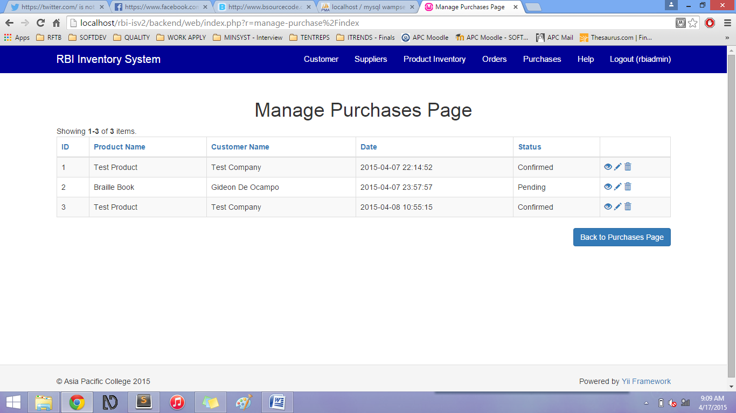

The user can view, update, and delete purchase information in the Manage Purchases Page using the icons on the right side (column name is blank):

* Eye icon – views chosen purchase information
* Pencil icon – edits chosen purchase information
* Trash bin icon – deletes chosen purchase information

#### Manage Purchases– View

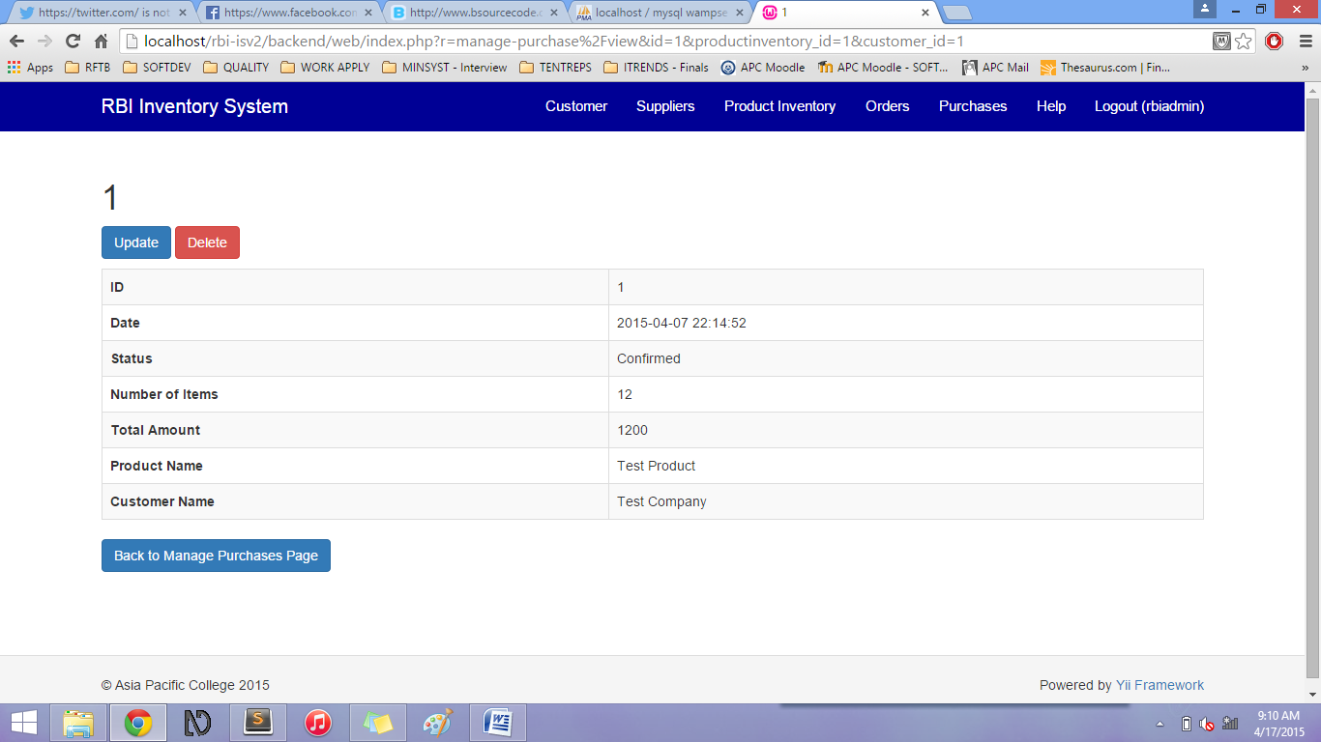

The View function (eye icon) shows the chosen purchase information.

Additional field: **Date** – this shows the Purchase date and the **Total Amount** shows the Purchased Number of Items multiplied by the Product Price.

You can also Update and Delete the information in this page.

You can also go Back to Manage Purchases after viewing the information.

#### Manage Purchase– Update

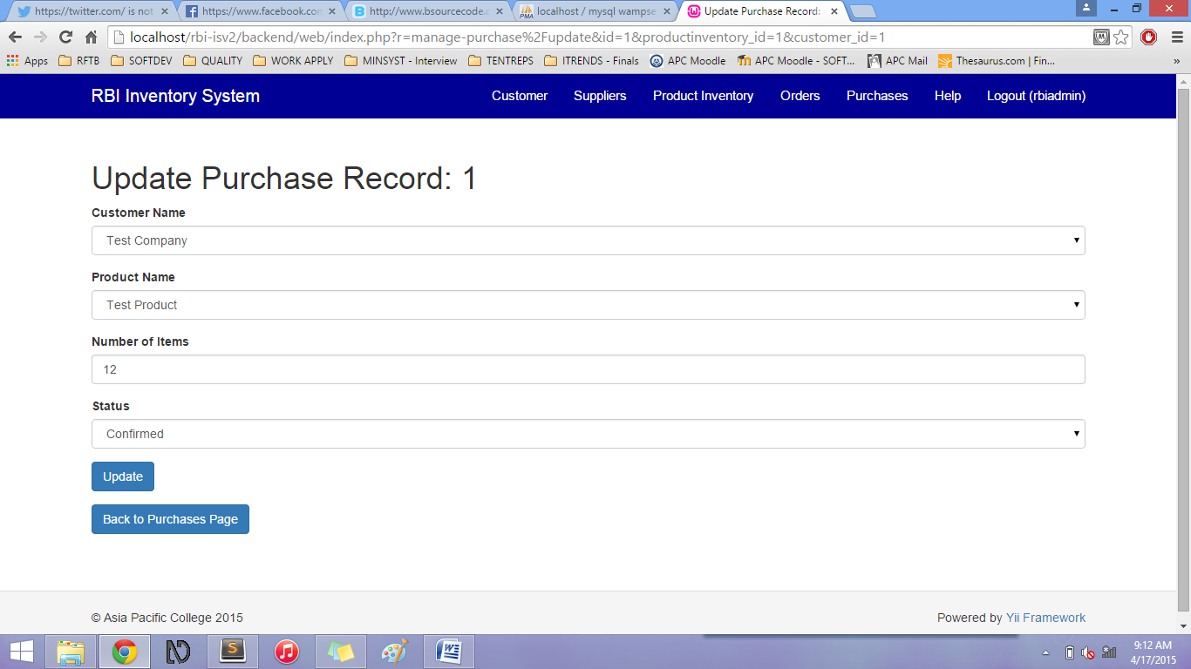

You can update the purchase information by clicking the Pencil icon.

Save the updated information by clicking the Update button.

You can go back to Purchases Page by clicking the Back to Purchases Page button.

#### Purchases Page – link (Optional Scenario)

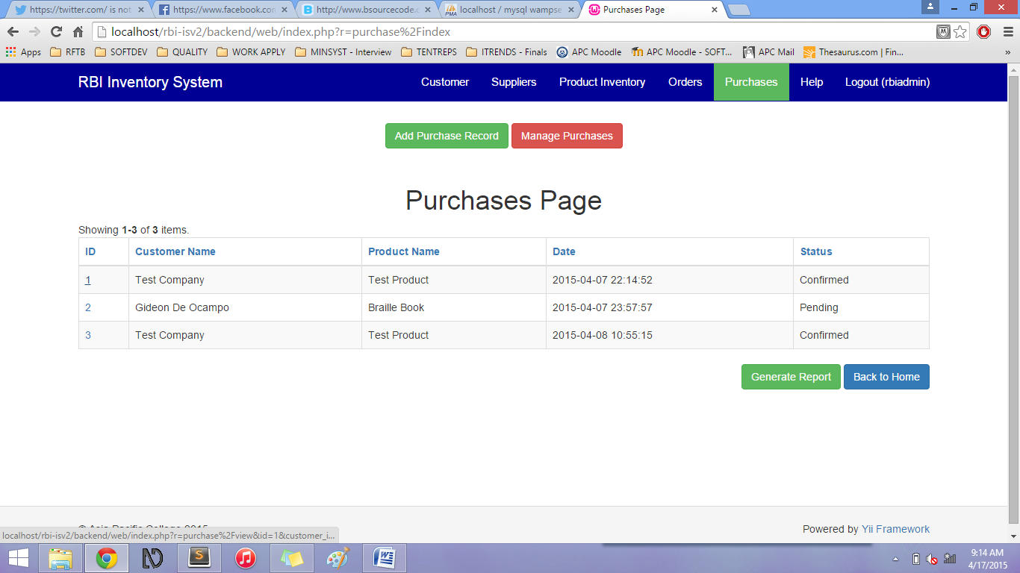

You can also view, update, and delete the Purchase information by clicking the link inside the Purchase ID column.

#### Purchases Page – sorting information

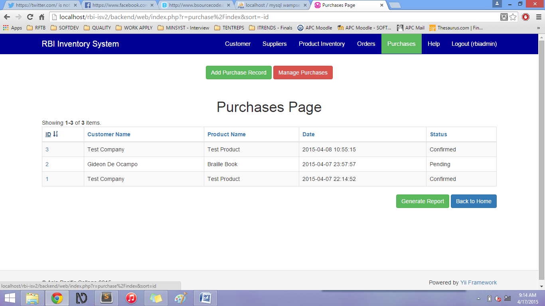

Sort the information presented by clicking on the Column name links. (All column names can be clicked to sort by ascending or descending order).

## Help Page

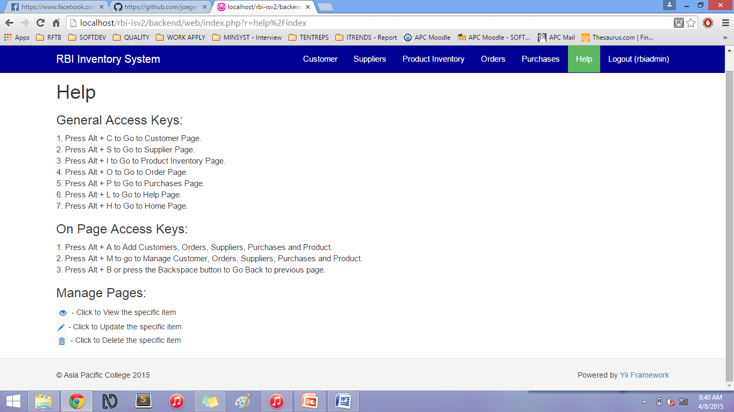

The Help Page includes the Instructions on how to navigate using the access keys, to know the functions of the button icons and site creators.

# Access Keys

### General Access Keys:

1. Press Alt + C to Go to Customer Page.  
2. Press Alt + S to Go to Supplier Page.  
3. Press Alt + I to Go to Product Inventory Page.  
4. Press Alt + O to Go to Order Page.   
5. Press Alt + P to Go to Purchases Page.  
6. Press Alt + L to Go to Help Page.  
7. Press Alt + H to Go to Home Page.

### On Page Access Keys:

1. Press Alt + A to Add Customers, Orders, Suppliers, Purchases and Product.  
2. Press Alt + M to go to Manage Customer, Orders, Suppliers, Purchases and Product.  
3. Press Alt + B or press the Backspace button to Go Back to previous page